: How to configure Rout53:

What Is Route 53 and How Does it Work?
Route 53 is a scalable Domain Name System (DNS) web service. It provides secure and reliable routing to your infrastructure that uses Amazon Web Services (AWS) products, such as Amazon Elastic Compute Cloud (Amazon EC2), Elastic Load Balancing, or Amazon Simple Storage Service (Amazon S3). You can also use Route 53 to route users to your infrastructure outside of AWS.
Route 53 is an authoritative DNS service, meaning it translates friendly domains names like www.example.com into IP addresses like 192.0.2.1. Route 53 responds to DNS queries using a global network of authoritative DNS servers, which reduces latency. For a list of the locations of Route 53 DNS servers, see The Amazon Route 53 Global Network on the Amazon Route 53 detail page.
You can manage your DNS records through the Route 53 console or the Route 53 API, or set account-level user and access management through the AWS Identity and Access Management (IAM) API.

Step 1: Sign Up for an AWS Account
To use Route 53, sign up for an AWS account if you don't already have one.
Note
When you sign up for an account, AWS automatically signs up the account for all services. You are charged only for the services that you use.

To sign up for an AWS account
- Go to http://aws.amazon.com, and then click Sign Up.
- Follow the on-screen instructions.
Part of the sign-up procedure involves receiving a phone call and entering a PIN using the phone keypad.

Step 2: Register Your Domain Name
Register your domain name. For a list of registrar web sites that you can use to register your domain name, see ICANN.org. After your registrar notifies you that your domain name is successfully registered, you can create a Route 53 hosted zone for the domain.

Step 3: Create a Hosted Zone
To create a domain that uses Route 53 as the DNS service, start by creating a Route 53 hosted zone. Route 53 stores information about your domain in the hosted zone.
Note
When you create a hosted zone, Route 53 automatically creates four name server (NS) records and a start of authority (SOA) record for the zone. The NS records identify the name servers that you give to your registrar or your DNS service so that queries are routed to Route 53 name servers. For more information about NS and SOA records, see NS and SOA Records that Route 53 Creates for a Hosted Zone.

To create a hosted zone using the Route 53 console
- Sign in to the AWS Management Console and open the Amazon Route 53 console at https://console.aws.amazon.com/route53/.
- In the Route 53 console, above the left pane, click Create Hosted Zone.
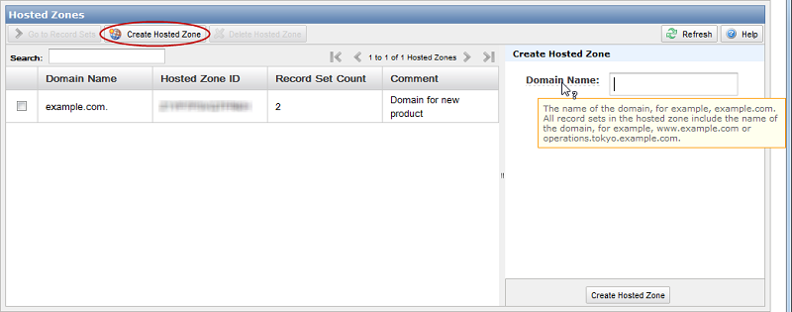
- In the right pane, enter a domain name and, optionally, a comment. For more information about a field, see the tool tip for the field.
- Below the right pane, click Create Hosted Zone.

Step 4: Create Resource Record Sets in Your Route 53 Hosted Zone
Now that you have a hosted zone, you can create resource record sets. For example, if you want a user who enters example.com in a web browser to be routed to a host that has the IP address 192.0.2.234, you would create a resource record set for example.com with a Type of A and a Value of 192.0.2.234.

To create resource record sets using the Route 53 console
- Sign in to the AWS Management Console and open the Amazon Route 53 console at https://console.aws.amazon.com/route53/.
- On the Hosted Zones page, do one of the following:
  - Click the row for the hosted zone in which you want to create record sets, and click Go to Record Sets.
  - Double-click the row for the hosted zone.
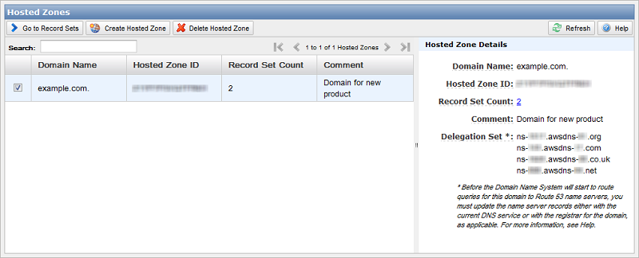
- On the Record Sets page, above the left pane, click Create Record Set.
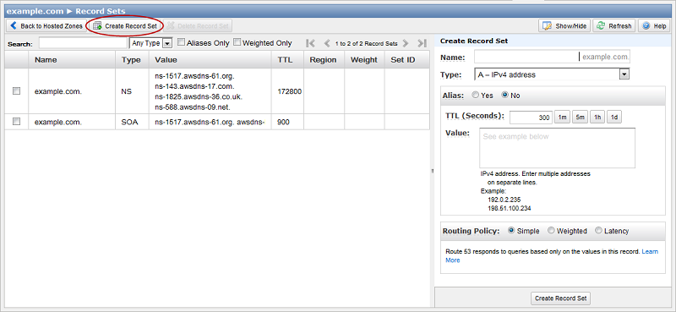
- In the right pane, enter the applicable values. For information about a field, see the tool tip for the field.
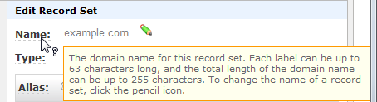
- Below the right pane, click Create Record Set.
Currently, the only way to verify that changes have propagated is by using the GetChange API action. Changes generally propagate to all Route 53 name servers in a couple of minutes. In rare circumstances, propagation can take up to 30 minutes.

Step 5: Update the Registrar's Name Server Records
Important
Use the following procedure only if you are creating a domain. If you're migrating an existing domain, or creating or migrating a subdomain, see the corresponding procedure in the applicable section:
- Migrating an existing domain to Route 53: see Updating Your DNS Service's Name Server Records.
- Creating a subdomain that uses Route 53 without migrating the parent domain: see Delegating Responsibility for the Subdomain to Route 53.
- Migrating a subdomain to Route 53 without migrating the parent domain: see Delegating Responsibility for the Subdomain to Route 53.
Update the name server (NS) records with your registrar to refer to the Route 53 name servers. Perform the following procedure.
- If the registrar has a method to reset the TTL settings for their name servers, we recommend that you reset the settings to 900 seconds. This limits the time during which client requests will try to resolve domain names using obsolete name servers. You will need to wait for the duration of the previous TTL for resolvers and clients to stop caching the DNS records with their previous values. A common default setting is 172800 seconds (two days). After the TTL settings expire, you can safely delete the records that are stored at the previous provider and make changes only to Route 53.
Note
The TTL setting is only an issue if you have queried the domain, so the domain name and IP address are cached with DNS resolvers.
- In the Route 53 console, get the name servers in the delegation set for your Route 53 hosted zone:
  - Sign in to the AWS Management Console and open the Amazon Route 53 console at https://console.aws.amazon.com/route53/.
  - On the Hosted Zones page, click the name of the hosted zone.
  - In the right pane, make note of the four servers listed for Delegation Set.
- Using the method provided by the registrar for the domain, replace the name servers in the registrar's NS records with the four Route 53 name servers that you looked up in the previous step.
Depending on the TTL settings for the name servers for the parent domain, the propagation of your changes to DNS resolvers can take 48 hours or more. During this period, DNS resolvers may still answer requests with the name servers for the registrar. In addition, client computers may continue to have the previous name servers for the domain in their cache.

